

American International University-Bangladesh (AIUB)  
**Department of Computer Science  
Faculty of Science &Technology (FST)  
Fall 19_20**

**Pharmacy Management System**

A software Engineering Sec: **(D)** project submitted By

*Zannat,Rahikul (17-33962-1)*

*Nahid,Nafiz Ahamed (17-34682-2)*

*Hossan,MD.Fayaj (17-33938-1)*

*Arafat Al Zami (17-34822-2)*

The project will be Evaluated for the following Course Outcomes

|  |  |
| --- | --- |
| CO3: Choose appropriate software engineering model in a software development environment | Total Marks |
|  |
| Content Knowledge [5Marks] |  |
| Argumentation [5Marks] |  |
| Evidence of Argumentation [5Marks] |  |
| Completeness, Spelling, grammar and Organization of the Answer [5Marks] |  |
|  | |
| CO4: Explain the roles and their responsibilities in the software project management activities | Total Marks |
|  |
| Project Background Analysis [5Marks] |  |
| Project Role identification [5Marks] |  |
| Responsibility Description [5Marks] |  |
| Completeness, Spelling, grammar and Organization of the Answer [5Marks] |  |

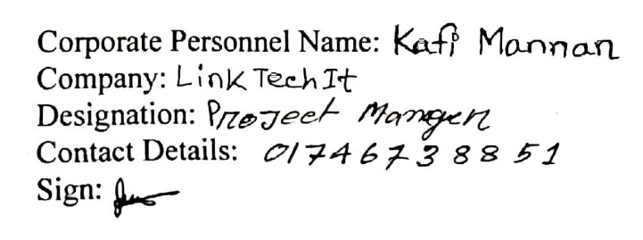

|  |  |
| --- | --- |
| **Content** | **Pages** |
| 1.Problem Domain  1.1 Background to the problem  1.2 Solution to the problem | 3-4 |
| 2.Solution Description  2.1 System Features | 4 |
| 3.UML Diagrams | 5-7 |
| 4.Software Development Life Cycle  4.1Process Model & Role Identification And Responsibilities | 7-9 |
| 5. Effort Estimation & Budget | 9-10 |
| 6. Scheduling | 10 |
| 7. Reference Link | 11 |

**Table Of Content:**

**1.Problem Domain**

**1.1 Background to the Problem**:

Pharmacy management system helps the users to buy their medicines in quick time with less effort. After open the software user can see different types of medicines. They can easily search their required medicine, they can also see available medicine pharmacies near him which contains his required medicine with also price and more details. With the search result the user can see so many pharmacies locations, but our software helps him to find the nearest possible pharmacy so that user can easily go and buy their medicine or user also can order online. With the help of this feature user don’t have to search their medicine pharmacy to pharmacy thoroughly. In quick time user can saw where he can find his medicine and how long it takes to reach their it will help the user to consume time in emergency. User can order their medicine through mobile apps or online webpage both options are available. The seller can update their database with price, availabilities. When new medicine comes, they can update into database. That will also help them to keep records of their products through the software.

**1.2** **Solution to the Problem:**

Before Pharmacy Management System come people face some problems, because they can’t order or buy medicine when they need in that much easily or in emergency, they have to run through pharmacy to pharmacy to find that one medicine he or she wanted. Sometimes the user luckily finds the pharmacy but there is not enough medicine. Then user have to run for the next pharmacy this thing kills his or her valuable time. If there is no pharmacy on his or her location what can he/she do??

On the other user don’t know all the price of the medicines. If user have insufficient balance and user don’t know the price about that medicine then user is in big trouble. There are lots of problems like this that user face everyday in their life.

Then comes the Pharmacy management system app to solve this that problems and helps the user and consume their time also helps them in their emergency because medicine is such thing that can be need anytime in short time. So, we offer our user to use this software to solve this problem. We have the better solutions. In daily life what kind of problems, they have to face we are trying to solve most of the problems. We give the privilege to our users so that they can see nearest pharmacy price of their required medicine and availability. They also can compare the price with other pharmacy if any one takes extra money they can also complain us. In some rare cases they can not have the time to go to the pharmacy and buy medicines in that case we are providing home delivery service for them 24/7.

**2.Solution Description**

**2.1 System Features:**

1. Registration:

It is not just a registration. In our registration we collect information very deeply. Medical document, medicine details and details are must. This registration details will help us for smart search.

1. User option:

One can added the products of medicine, one can deleted the product of medicine and one can updated the product of medicine. Another user can got the information of the medicine products. The software will integrate both user throughout the process.

1. Advanced /smart search:

If someone is buy some medicines, the software will provide the location of medicine shop lists and which medicine are contains in there shop. People can easily found the medicine shop nearby.

1. Place Order:

Pharmacy can place order and admin list down his order and he place that order to the medicine company. Customer can check the medicine through the software and he have to pay his bill to the pharmacy there is no delivery system.

**3.UML Diagrams**

**Use Case Diagram:**

There are two type of user interface for operate this pharmacy management system. This system has login using id, password for both actors. Where the primary actor can search for the product and see the availability and price of their desired product. And the secondary actor verifies the user, monitoring the system and do transaction with the user

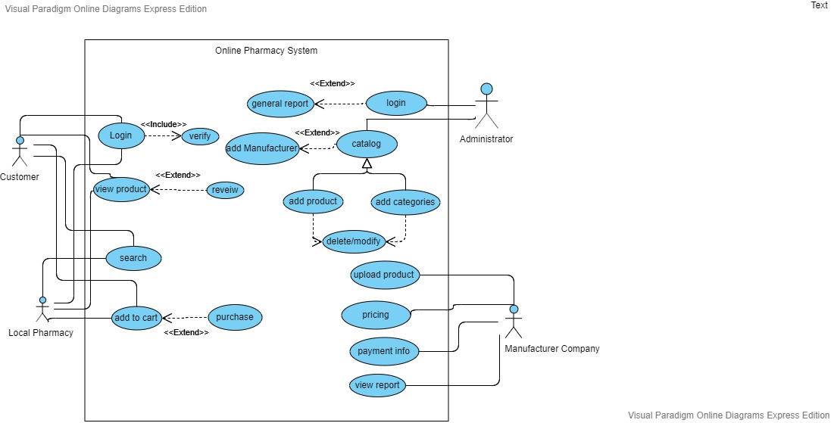

Fig: Use Case Diagram

**Class Diagram:**

Here is the class diagram of the system. The Administrator class manage the customer and the Pharmacy class. This class also handle the order from the pharmacy and make contact with the company class. Company class has their inventory from where they manage the supply. They have also medicines class where they fixed the price of each quantity of the medicine. And for pharmacy they have stock class where they trace how much medicine they have and how much they need to order.

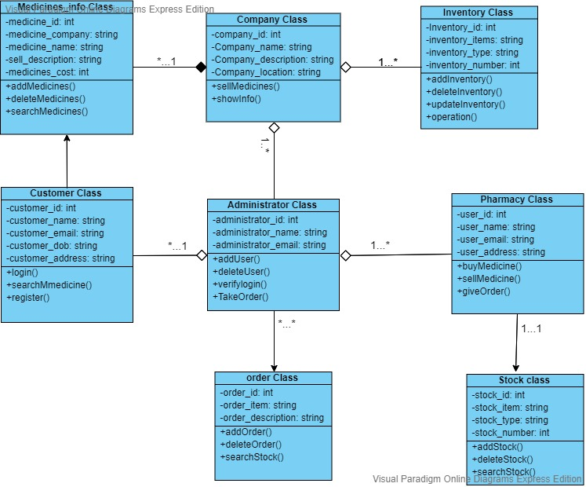

Fig: Class Diagram

**Activity Diagram:**

This diagram represents the relation among the entity class. This explain that both users require login for the system. Where the Customer can search the medicine to see its price and availability. And the pharmacy can give order which is manage by the admin. Medicine company can directly contract with the admin for any queries. Medicine are made by the company and they set up the price and availability.

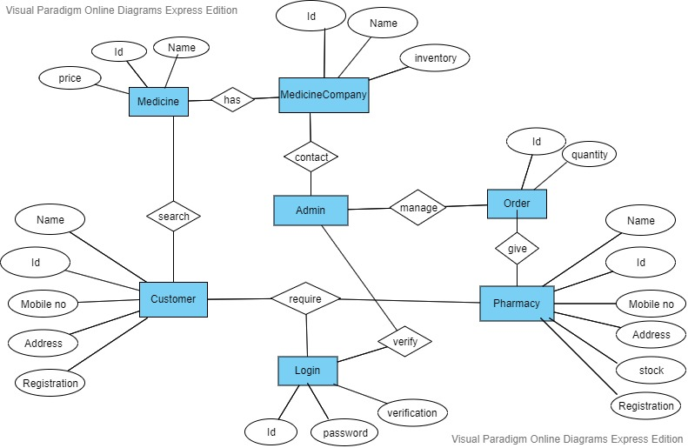

Fig: Activity Diagram

**4.Software Development Life Cycle**

**4.1 Process Model & Role Identification And Responsibilities:**

The project is done by Rapid Application Development (RAD) model. Because of it is a type of incremental model. The developments are time boxed, delivered and then assembled into a working prototype. In RAD model the components or functions are developed in parallel as if they were mini projects. We can easily see and to provide the feedback. There are four levels or phases for classifying the roles within Rapid Application Development (RAD). Those are

* + Requirements Planning
  + User Design
  + Construction
  + Cutover

1. **Requirements Planning:**

It is a project scoping meeting. Although the planning phase is condensed compared to other project management methodologies, this is a critical step for the ultimate success of the project. In this phase, developers, clients and team members are discuss to determine the goals and expectations for the project that would need to be addressed during the build.

Rahikul Jannat will be in the requirements planning as a project manager.

1. **User Design:**

Once the project is scoped out, it’s time to jump right into development, building out the user design through various prototype iterations. In this phase, clients work hand in hand with developers to ensure their needs are being met at every step in the design process. Both the software developers and the clients learn from the experience to make sure there is no potential for something to slip through the cracks.

Nafiz Nahid will be in the user design as a designer.

Fayaj Hossan will be in the user designer as an analyst.

1. **Construction:**

Construction takes the prototype and beta system from the design phase and converts them into the working model. Because the majority of the problems and changes were addressed during the thorough iterative design phase, developers can construct the final working model more quickly than they could by following a traditional project management approach. This third phase is important because the client still gets to give input throughout the process. They can suggest alterations, changes, or even new ideas that can solve problems as they arise.

1. **Cutover:**

In this phase, the software is implementation where the finished product goes to launch. It includes data conversion, testing, and changeover to the new system, as well as user training. All final changes are made while the coders and clients continue to look for bugs in the system.

Al Zami Arafat will be in the cutover as a tester of the project.

**5. Effort Estimation & Budget:**

|  |  |
| --- | --- |
| **Task** | **Hours To Complete** |
| System Analyser (1P) | 16 |
| Designer(2P) | 48 |
| Frontend (2P) | 16 |
| Backend(2P) | 48 |
| Full Function Review | 16 |
| Overall Review | 16 |
| Quality Assurance(1P) | 24 |
| Maintenance | 6 month free |

Total Working Hour = 192 hours

Daily Working Hour = 8 hours

System Analyser: 1p*(300 tk P/H)*16= 4,800 tk

Designer: 2p*(200 tk P/H)*48= 19,200 tk

Frontend: 2p*(300 tk P/H)*16= 9,600 tk

Backend: 2p*(750 tk P/H)*48= 72,000 tk

Quality Assurance: 1p*(200 tk P/H)*24= 4,800 tk

Utility & other = 30,000 tk

Total Hour rate= 731.25 tk

Total Cost = (731.25*192)

= 1,40,400 tk

**6. Scheduling:**

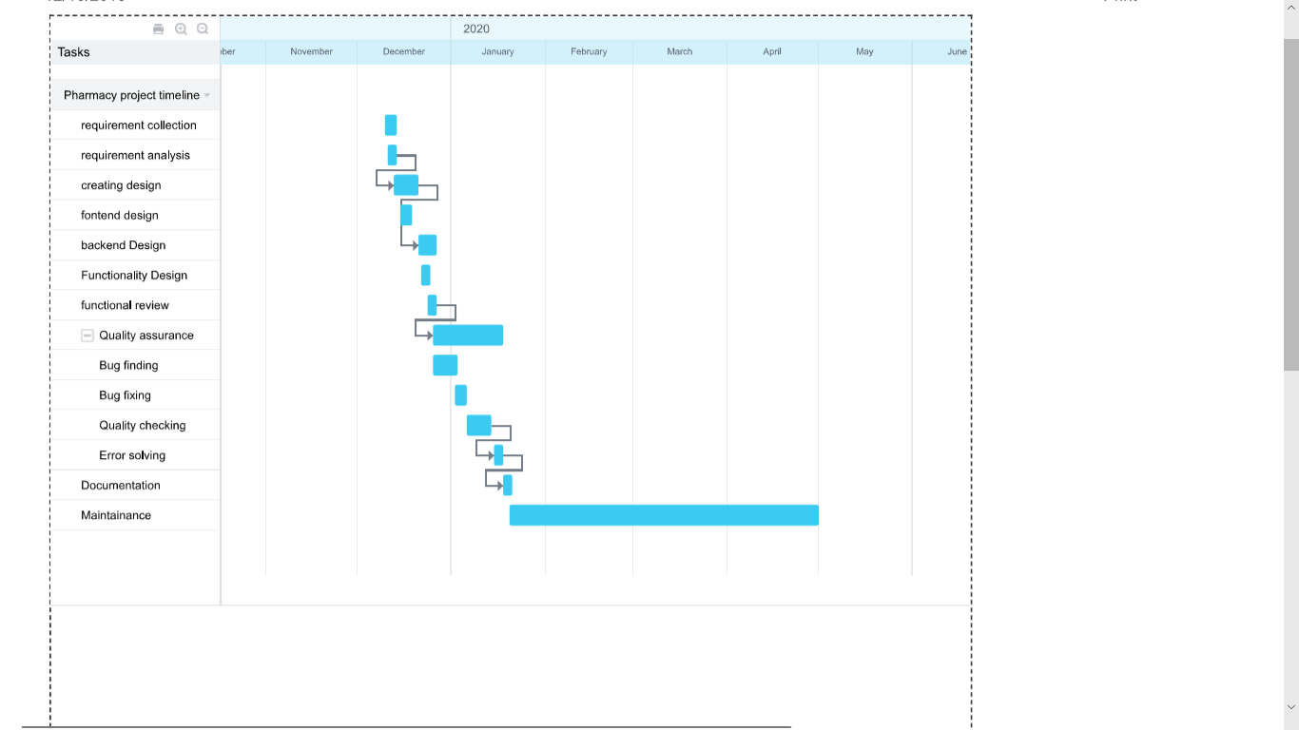

**7. Reference Link:**

**1.**Uml use case diagram [https://online.visual-paradigm.com/w/lpffyjbc/diagrams/#](https://online.visual-paradigm.com/w/lpffyjbc/diagrams/)

**2.**Uml class diagram [https://online.visual-paradigm.com/w/lpffyjbc/diagrams/#](https://online.visual-paradigm.com/w/lpffyjbc/diagrams/)

**3.**Scheduling Estimation <https://b24-ud3rzc.bitrix24.com/company/personal/user/1/tasks/?F_STATE=sVg0>

**4.** Book: R.S. Pressman & Associates, Inc. (2010). *Software Engineering: A Practitioner’s Approach.*